Sean Lee

Professor Imielinski

CS 336

3 October 2022

1. Find all distinct drinkers whose phone numbers come from area code 917 and who like Budweiser or Bud (synonim!)

SELECT DISTINCT l.drinker

FROM Drinkers d, Likes l

WHERE (d.phone LIKE '917-%') AND (l.beer="Budweiser" OR l.beer = "Bud") AND (d.name=l.drinker);

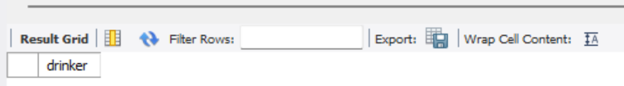

1. What beers does Mike like?

SELECT name AS beer_name

FROM Beers

WHERE name IN

(

SELECT beer

FROM Likes

WHERE drinker = 'Mike'

);

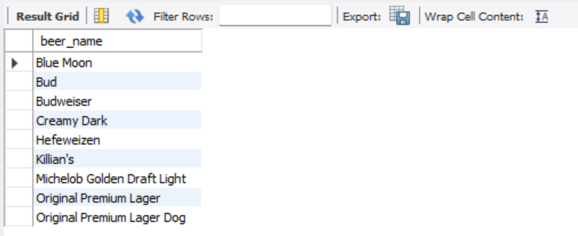

1. Which town has the most drinkers?

SELECT city

FROM Drinkers group by city order by COUNT(name) DESC

lIMIT 1;

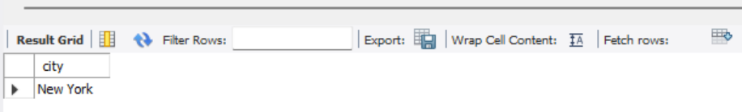

1. What bars are frequented by drinkers from that town (3)?

SELECT DISTINCT bar

FROM Frequents

WHERE drinker IN

(

SELECT name

FROM Drinkers AS d

JOIN

(

SELECT city

FROM Drinkers group by city order by COUNT(name) DESC

LIMIT 1

) AS d2

ON d.city

IN (d2.city)

);

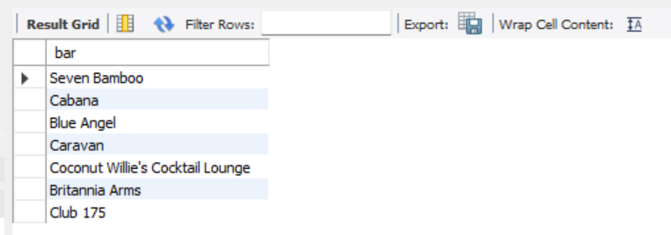

1. Provide all bars which serve beers that Mike likes

SELECT DISTINCT name AS bar_name

from Bars, Sells s

WHERE s.beer in

(

SELECT name

FROM Beers

WHERE name IN

(

SELECT beer

FROM Likes

WHERE drinker = 'Mike'

)

);

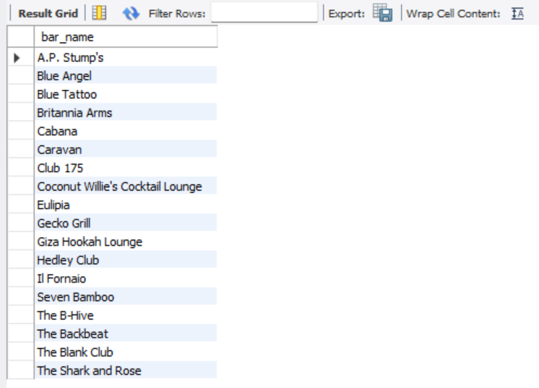

1. Who likes at least one same beer that Joe or Mike like?

SELECT DISTINCT l1.drinker

FROM Likes AS l1, Likes AS l2

WHERE l1.beer = l2.beer AND l1.drinker!='Mike' AND l1.drinker != 'Joe';

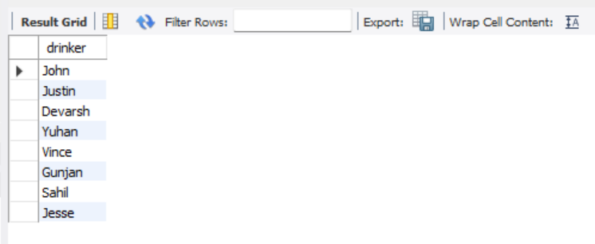

1. All bars which sell at least one beer which is liked by at least one drinker who frequents these bars

SELECT DISTINCT f.bar

FROM Sells, Likes, Frequents f

WHERE Sells.beer=Likes.beer AND f.drinker=Likes.drinker;

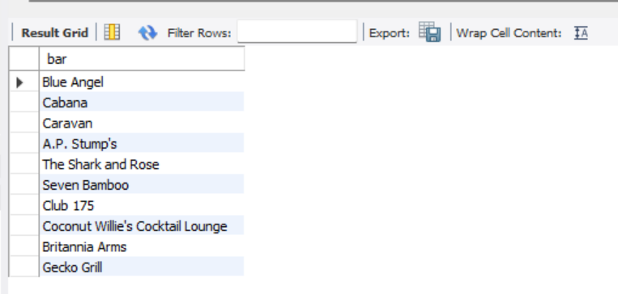

1. Drinkers who like some beers sold by Caravan bar

SELECT DISTINCT drinker

FROM Sells, Likes

Where Sells.bar='Caravan' AND Sells.beer=Likes.beer;

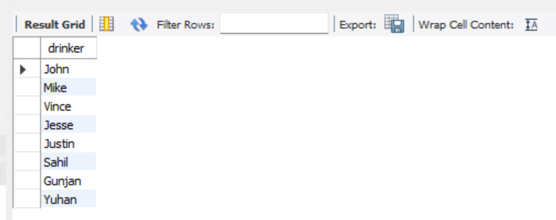

1. Bars which sell Budweiser and are frequented by some drinkers who like Budweiser

SELECT DISTINCT f.bar

FROM Sells AS s, Likes, Frequents AS f

WHERE s.beer='Budweiser' AND Likes.beer='Budweiser' AND f.drinker=Likes.drinker;

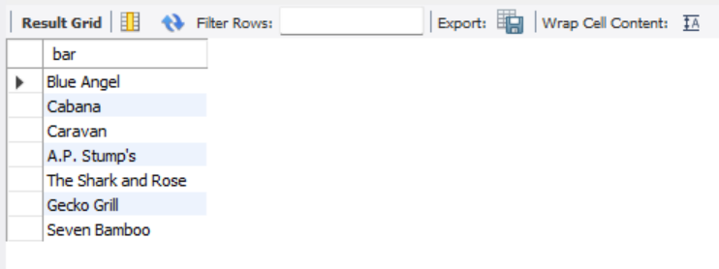

1. Bars which are frequented by Mike and Steve

SELECT f1.bar

FROM Frequents f1, Frequents f2

WHERE f1.drinker='Mike' AND f2.drinker='Steve' AND f1.bar=f2.bar;

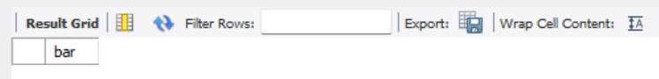

1. Drinker who like at least two beers that Mike likes

SELECT DISTINCT personbeer1.drinker

FROM Likes personbeer1, Likes personbeer2, Likes mike1, Likes mike2

WHERE

personbeer1.drinker!='Mike' AND

mike1.drinker='Mike' AND

mike2.drinker='Mike' AND

personbeer1.drinker=personbeer2.drinker AND

personbeer1.beer!=personbeer2.beer AND

personbeer1.beer=mike1.beer AND

personbeer2.beer=mike2.beer AND

mike1.beer!=mike2.beer;

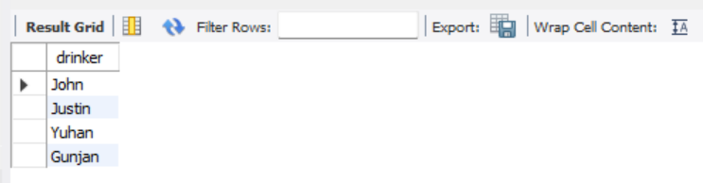

1. Bars which sell at least 3 beers that Mike likes (do not use COUNT)

SELECT DISTINCT s1.bar

FROM Likes l1, Likes l2, Likes l3, Sells s1, Sells s2, Sells s3

WHERE

l1.beer=s1.beer AND

l2.beer=s2.beer AND

l3.beer=s3.beer AND

l1.drinker='Mike' AND

l2.drinker='Mike' AND

l3.drinker='Mike' AND

l1.beer!=l2.beer AND

l1.beer!=l3.beer AND

l2.beer!=l3.beer AND

s1.beer!=s2.beer AND

s1.beer!=s3.beer AND

s2.bar!=s3.beer AND

s1.bar=s2.bar AND

s1.bar=s3.bar AND

s2.bar=s3.bar;

